

What versions are you running?
You can quickly check the version numbers of all the Apps installed on a V-R by going to:
‘Settings > REG SETTINGS > Device (Tab) > Apps Version List’
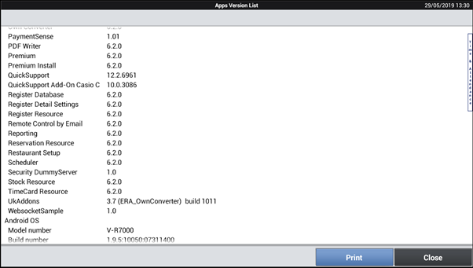
The ‘Print’ button will also print off a copy of this list on the configured Receipt printer. It’s a good idea to print this off at the end of an installation and keep it with your records for that customer –you then have a paper record of exactly what was installed on day one for that customer.

Using the ‘SETTING’ Clerk to program the V-R
By signing on to the V-R using the ‘SETTING’ clerk you can program buttons directly from the registration screen.
1. Log on using the ‘SETTING’ clerk.
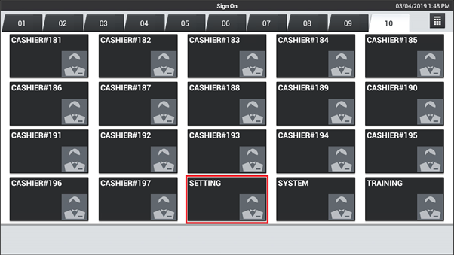
2. Tap and hold the button that you wish to reprogram to display the available options.
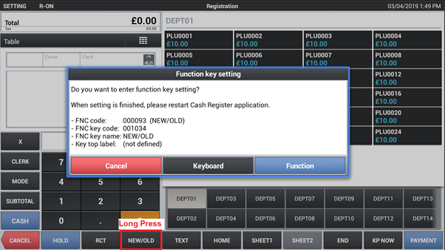
3. Tap ‘Function’ to take you directly to the function programming for that key.
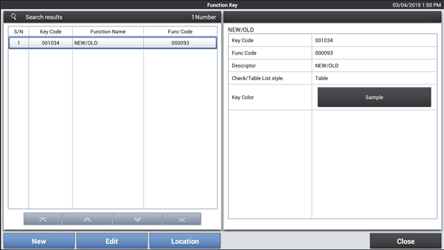
4. Tap ‘Keyboard’ to take you directly to the keyboard programming for that key.

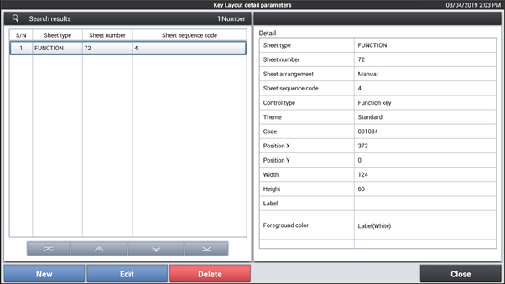

Your changes will take effect after restarting the app (you will be prompted to do so).
This functionality is very powerful and customisable. For further details, look in the online V-R manual in ‘Top Menu – ‘Settings’ > REG SETTINGS > Clerk (Tab) > Clerk Group > Setting Clerk’

